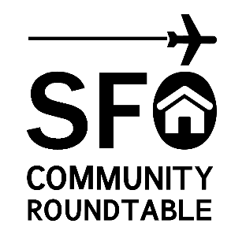
Meeting Announcement
Legislative Subcommittee
Thursday, July 13, 2017
10:00 a.m. – 12 noon

San Mateo County Office Building 455 – Room 201
455 County Center – Redwood City

Conference Call / Webcast: http://sforoundtable.org/webcast/

Note: To arrange an accommodation under the Americans with Disabilities Act to participate in this public meeting, please call (650) 363-1853 at least 2 days before the meeting date.
1

AGENDA

1. Call to Order

2. Follow-up, Quiet Skies Caucus and House Appropriations Transportation Subcommittees

3. Discussion, Congressional Legislation regarding FAA and airline industry.

4. Discussion, Outreach with other aviation noise groups.

5. Discussion, Airline outreach regarding equipment upgrades, and public relations campaign.

6. Public Comments on Items NOT on the Agenda
*Speakers are limited to two minutes. Roundtable members cannot discuss or take action on any matter raised under this item.

7. Adjourn

